CONFIGURE FRIEND INVITER

I. GOOGLE PROVIDER
- Go to Google API Console https://console.developers.google.com, Click on New Project to create new project or select the exist project

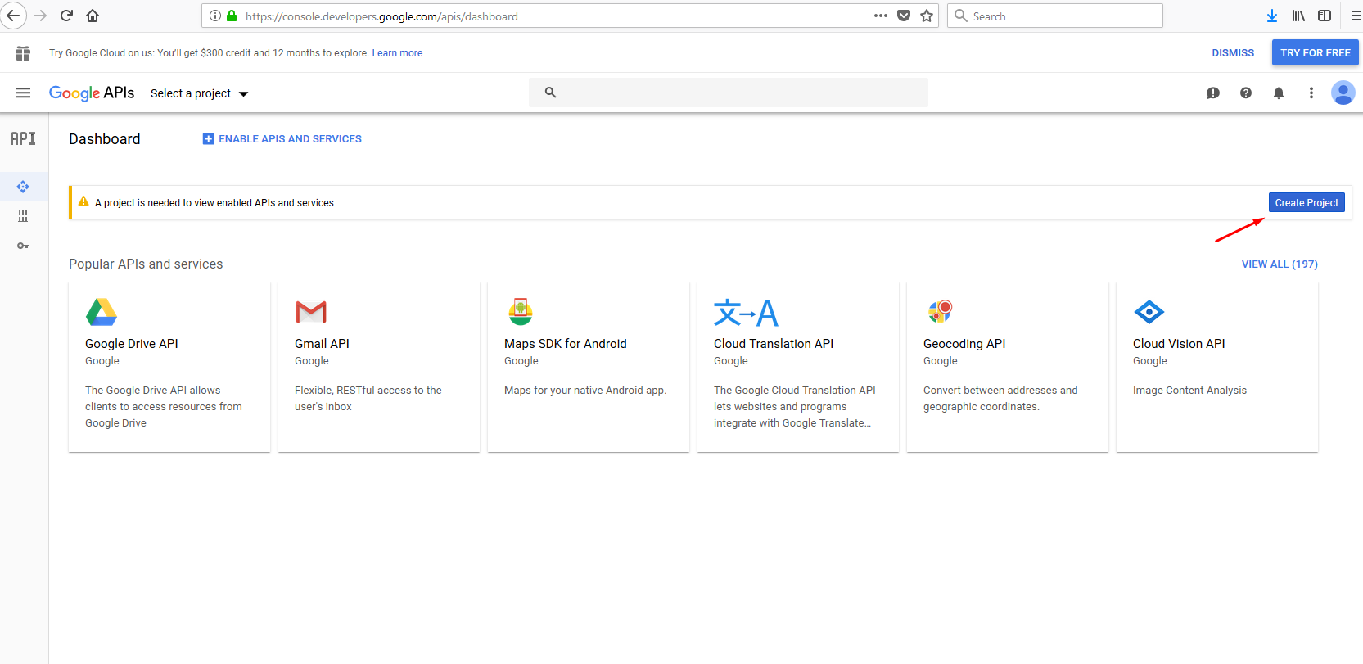
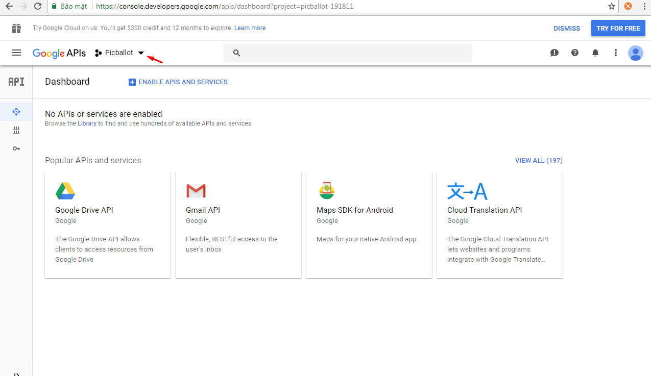

- On “New Project” screen, enter Project name then click “Create” button to create new project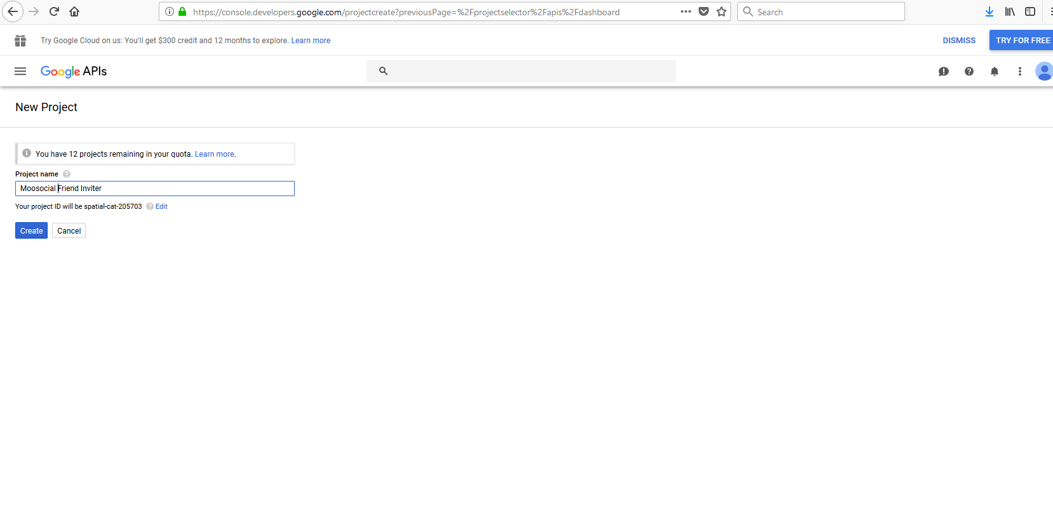
- After the project create successful, click on “ENABLE APIS AND SERVICES”
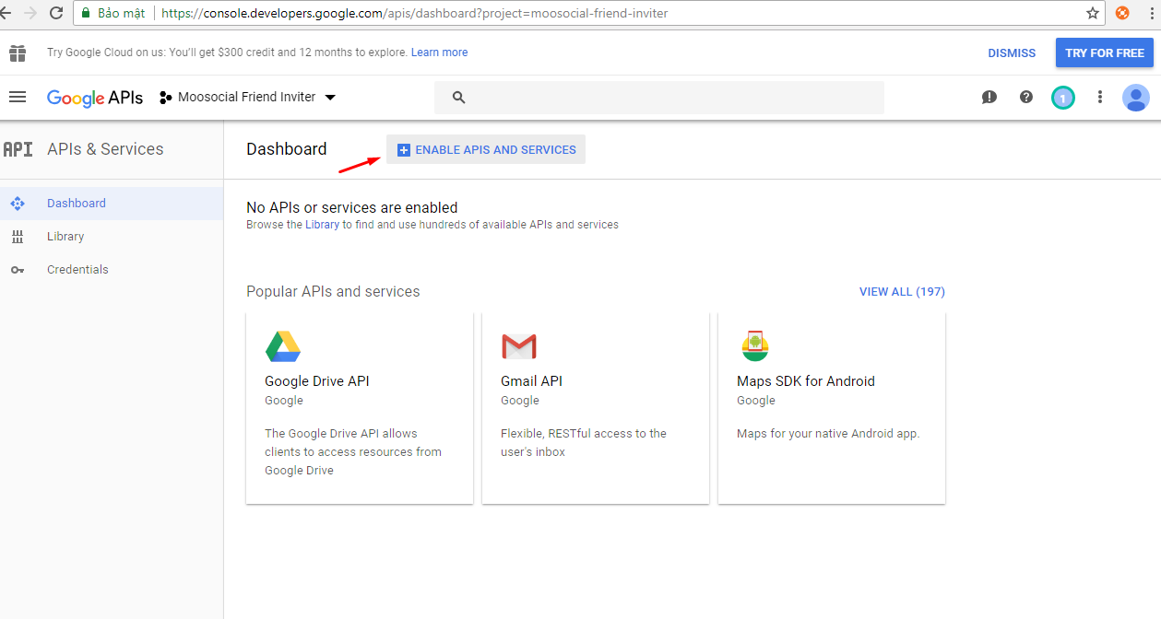

- Enter Google+ in Search box , then click on Google+ API
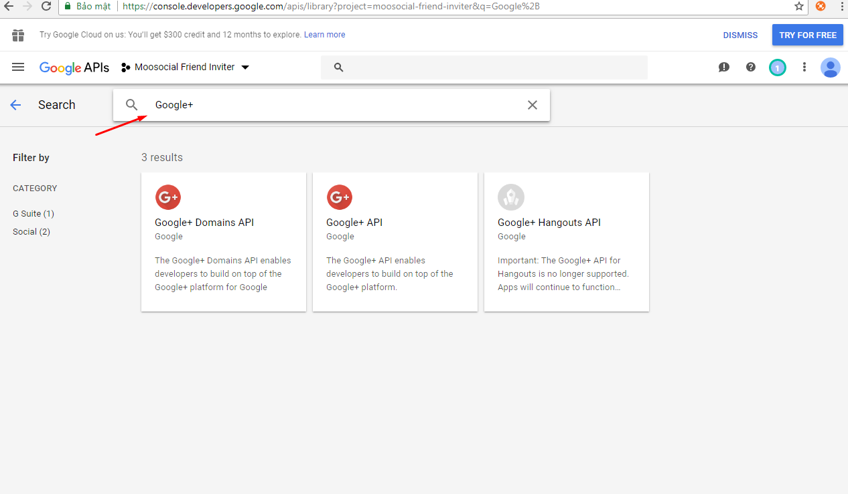

- Click on button “ENABLE” to enable this API
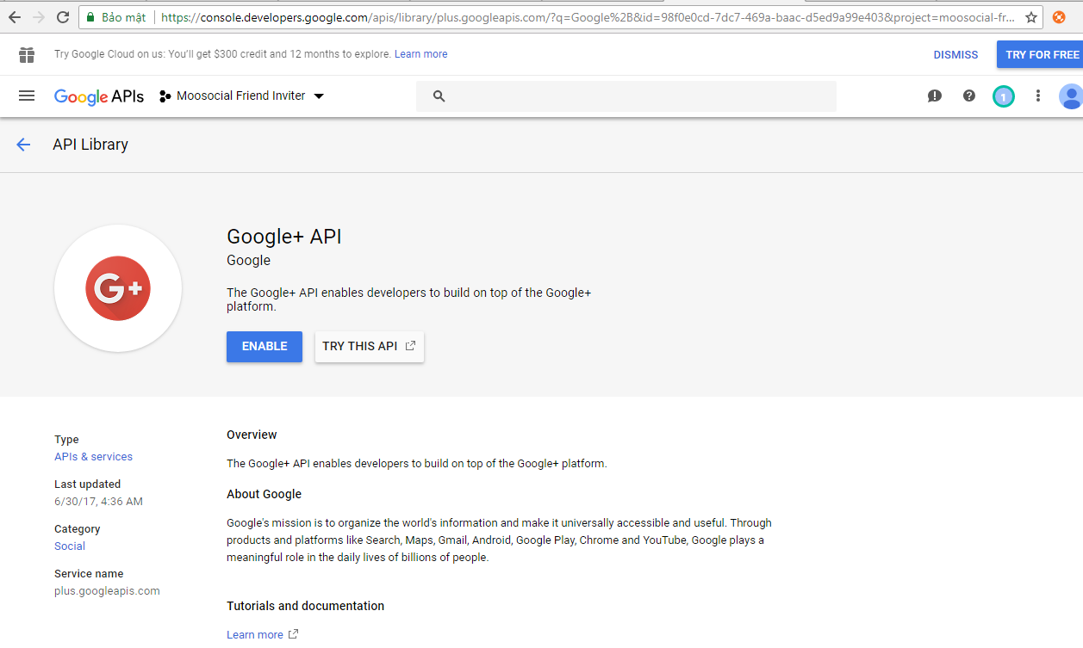

- Click on Navigation >> APIs & Services >> Library

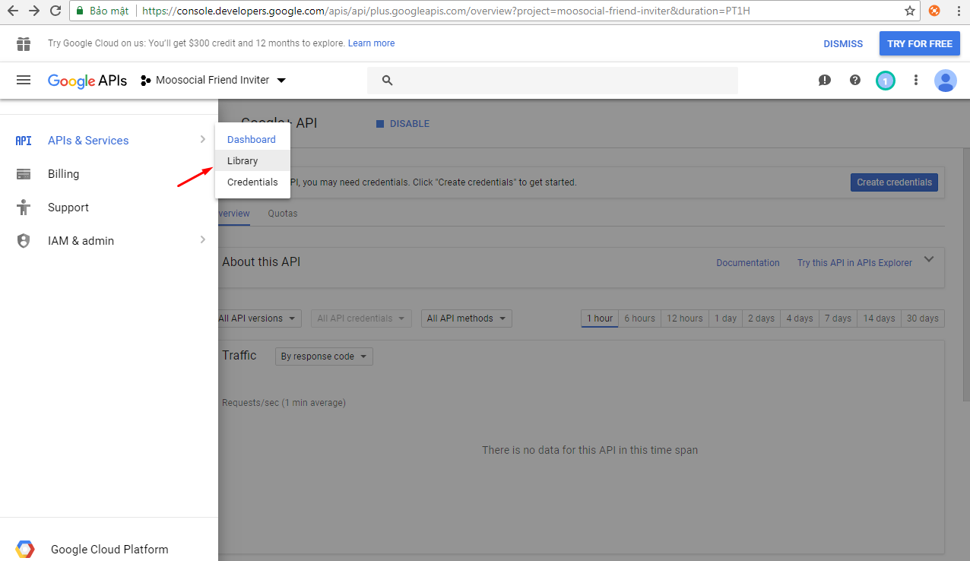

- Enter Contacts in Search box , then click on Contacts API. Continue enable Conracts API

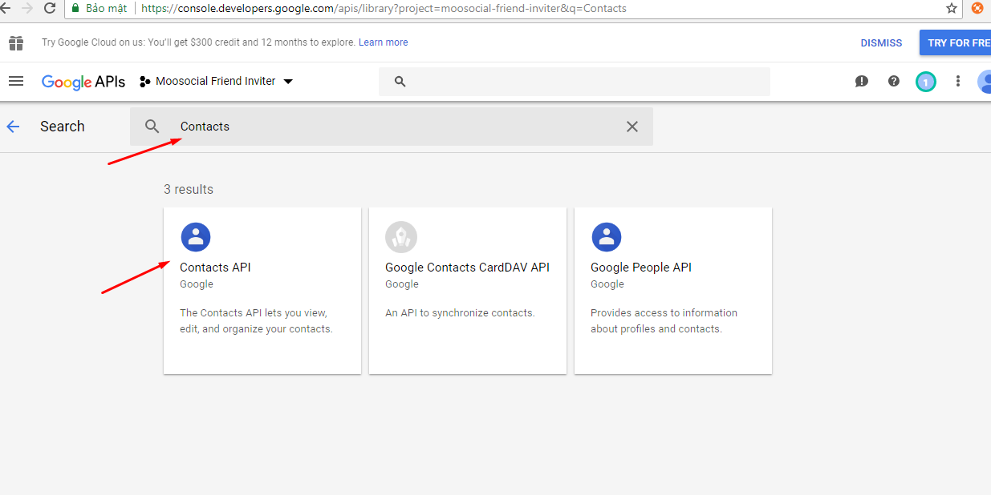

- Click on Credentials menu item

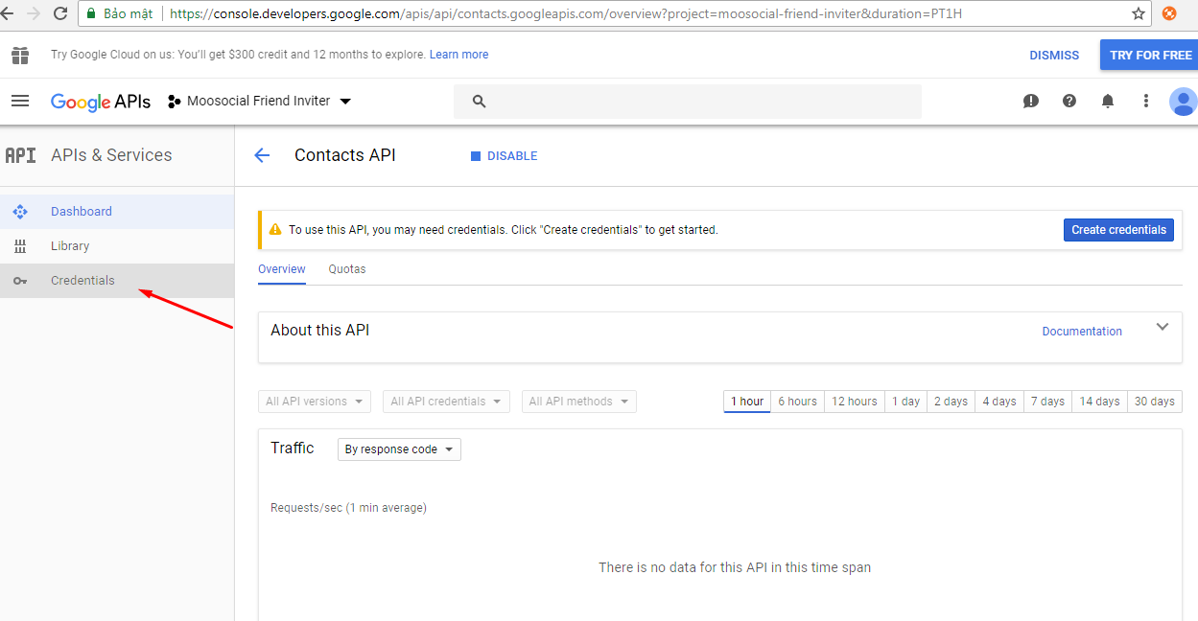

- On Credentials page, click on Create credentials >> Oauth client ID

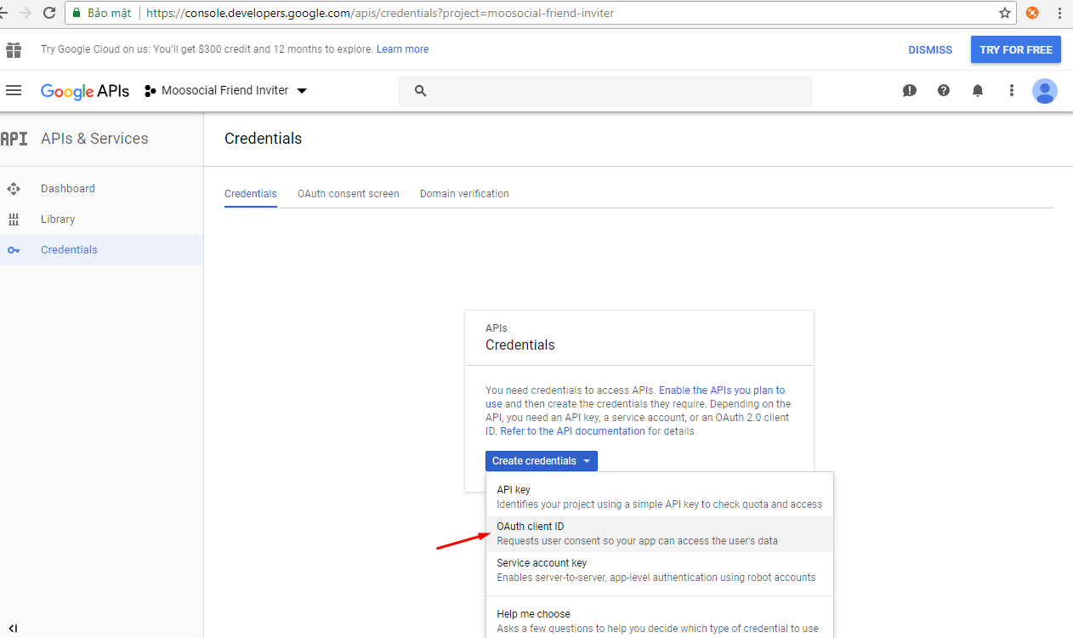

- Click “Configure consent screen” if we do not set a product name yet

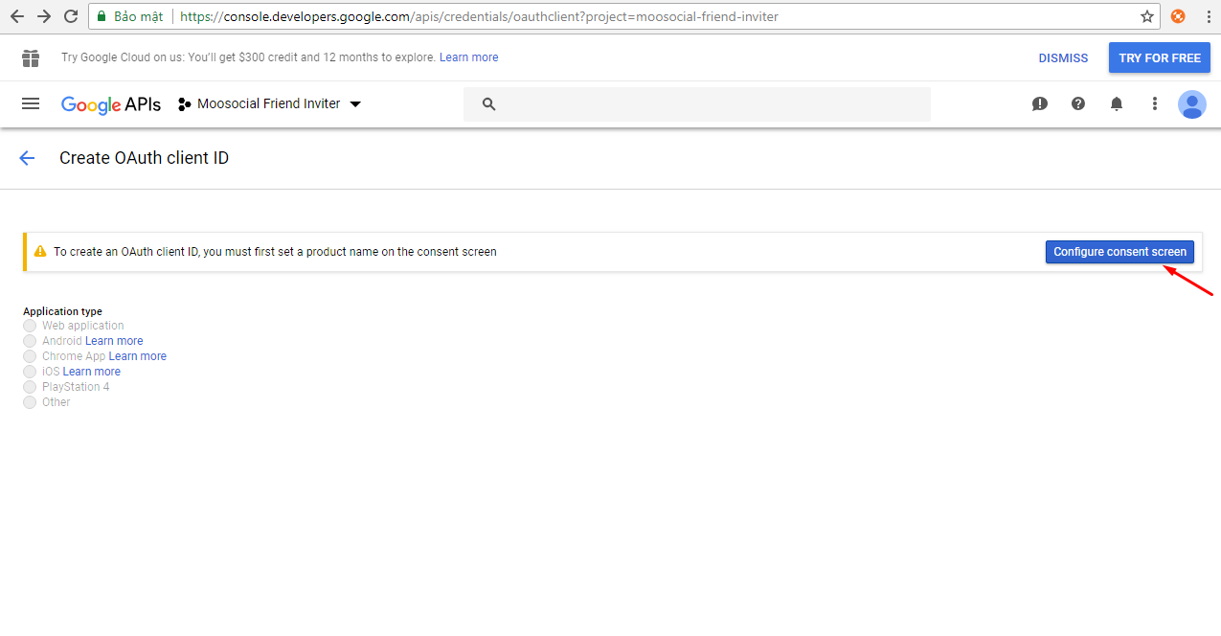

- Enter Product name show to users, then click Save button
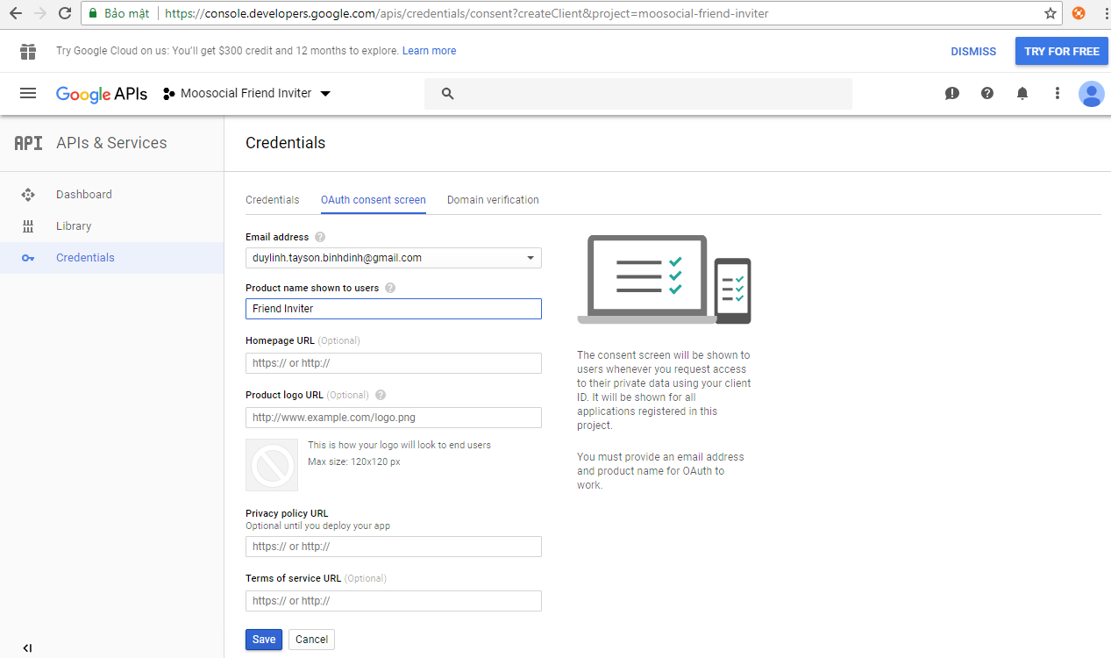

- Adding the exact Authorized redirect URI: [url_your_site]/friend_inviters/getcontacts?hauth_done=Google (Example : http://www.mysite.com/friend_inviters/getcontacts?hauth_done=Google), then click “Create”

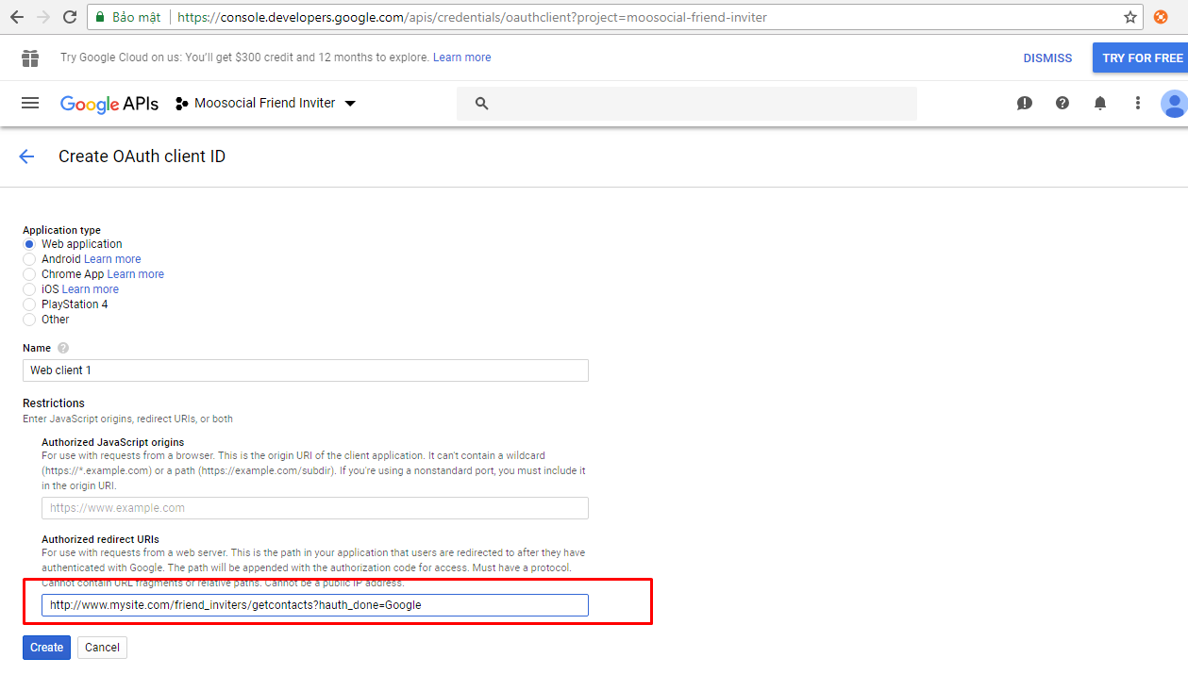

- Copy client ID and client secret and paste these values in your site's Google contact importer settings fields.

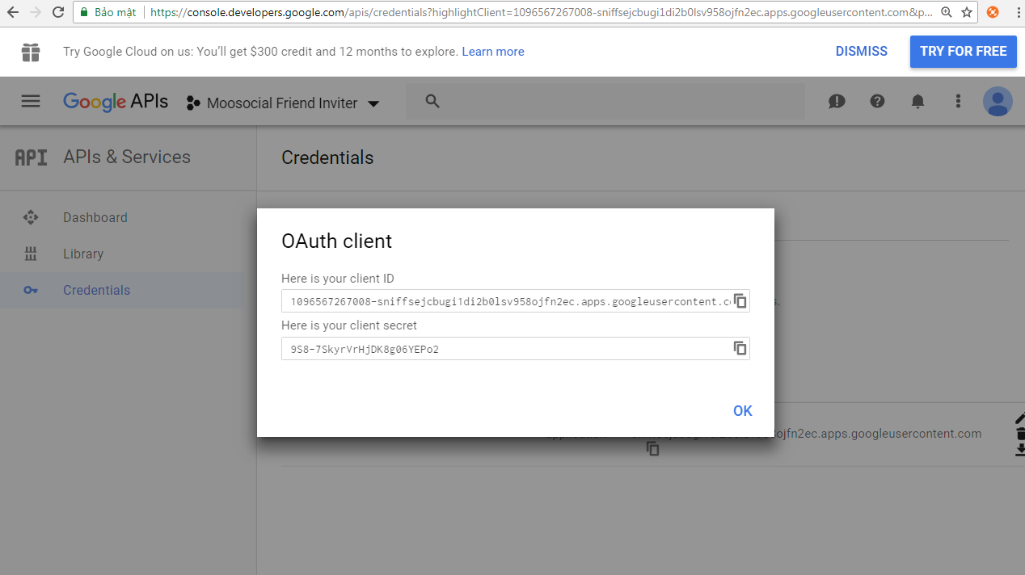
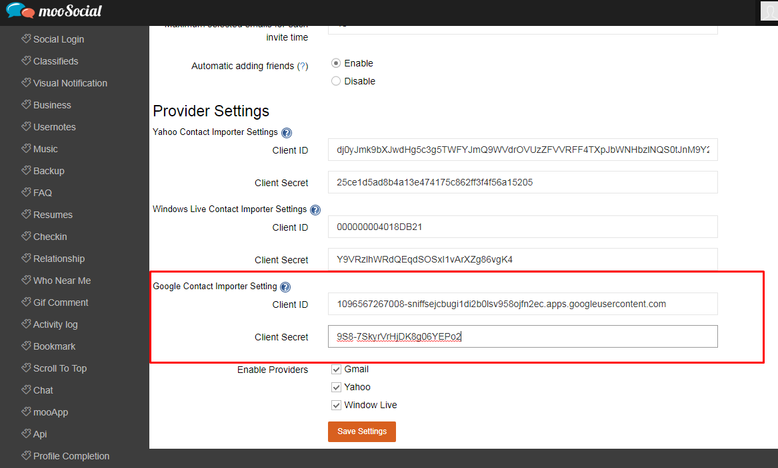

- Finally, click “Save Setting” to save Google Contact Importer Settings

II. YAHOO PROVIDER
- Go to https://developer.yahoo.com/apps/ and click “Create an App”

- Fill your application infos, then click “Create App” to create your application
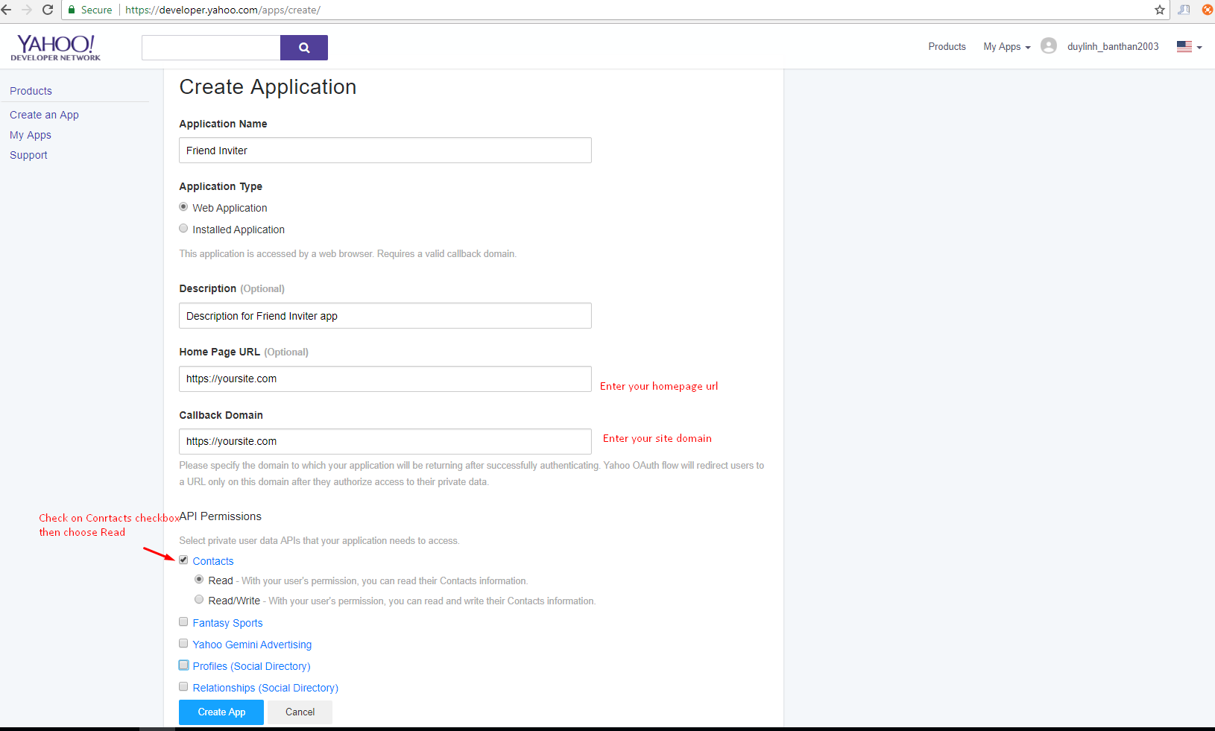

- Copy Client ID and Client Secret and paste these values in your site's Yahoo contact importer settings fields.

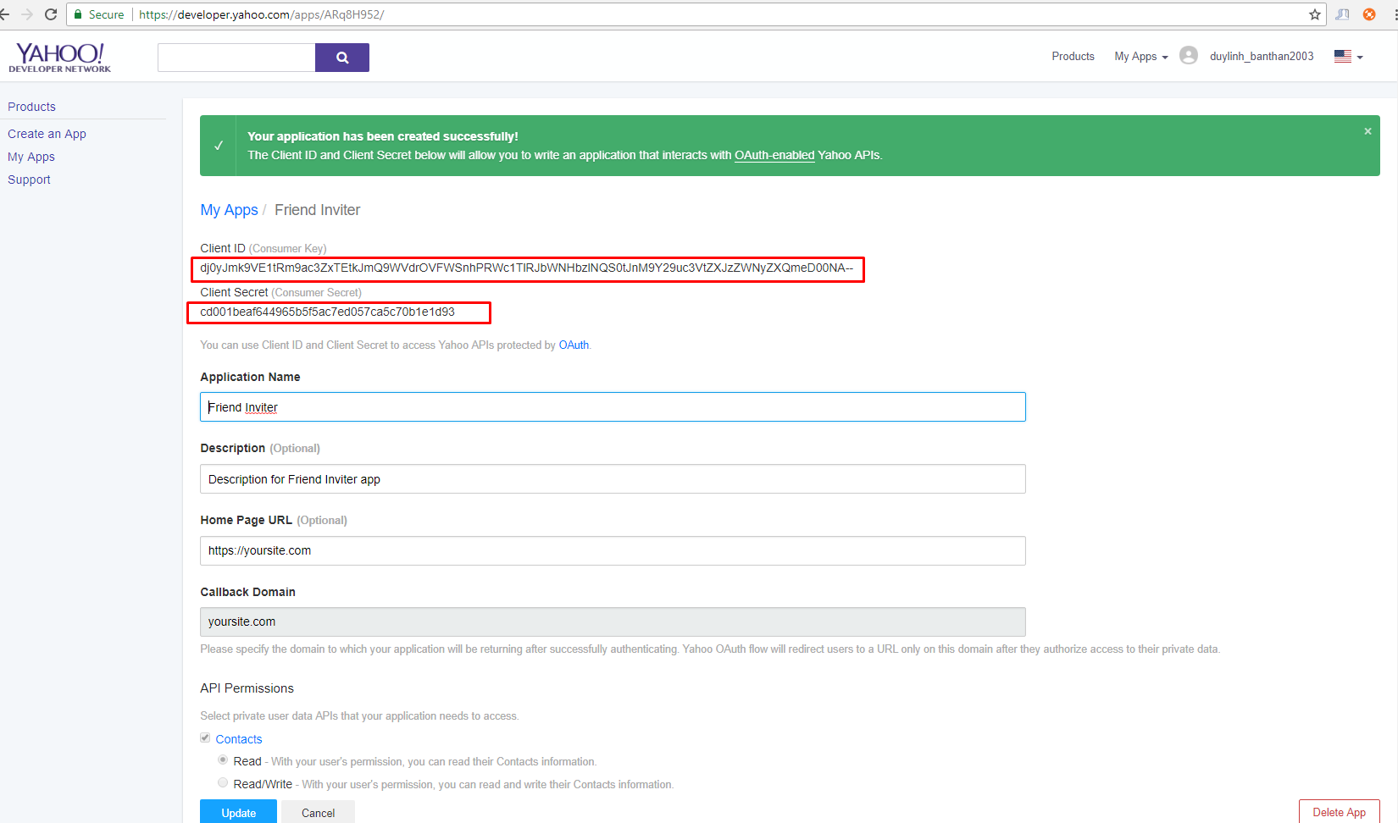
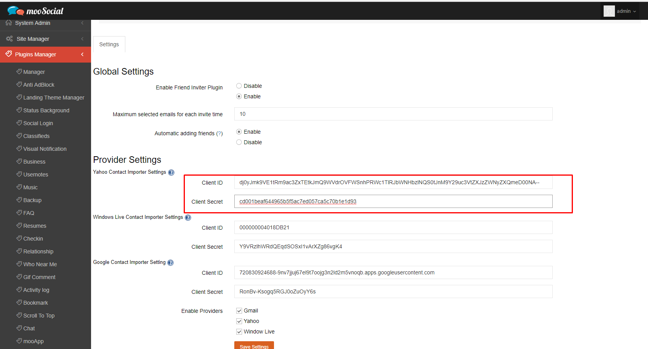

- Finally, click “Save Setting” to save Yahoo Contact Importer Settings

III. LIVE PROVIDER
- Go to https://apps.dev.microsoft.com, then click on Add an app (Converged applications)

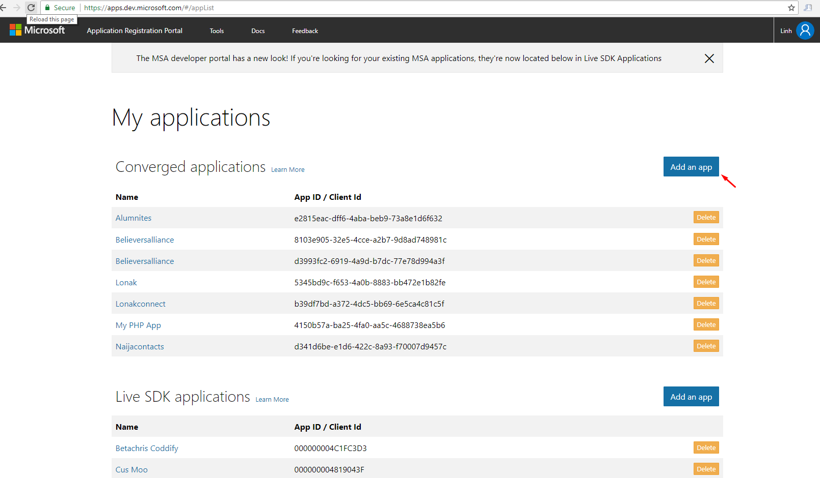

- Enter your Application Name, then click “Create” button

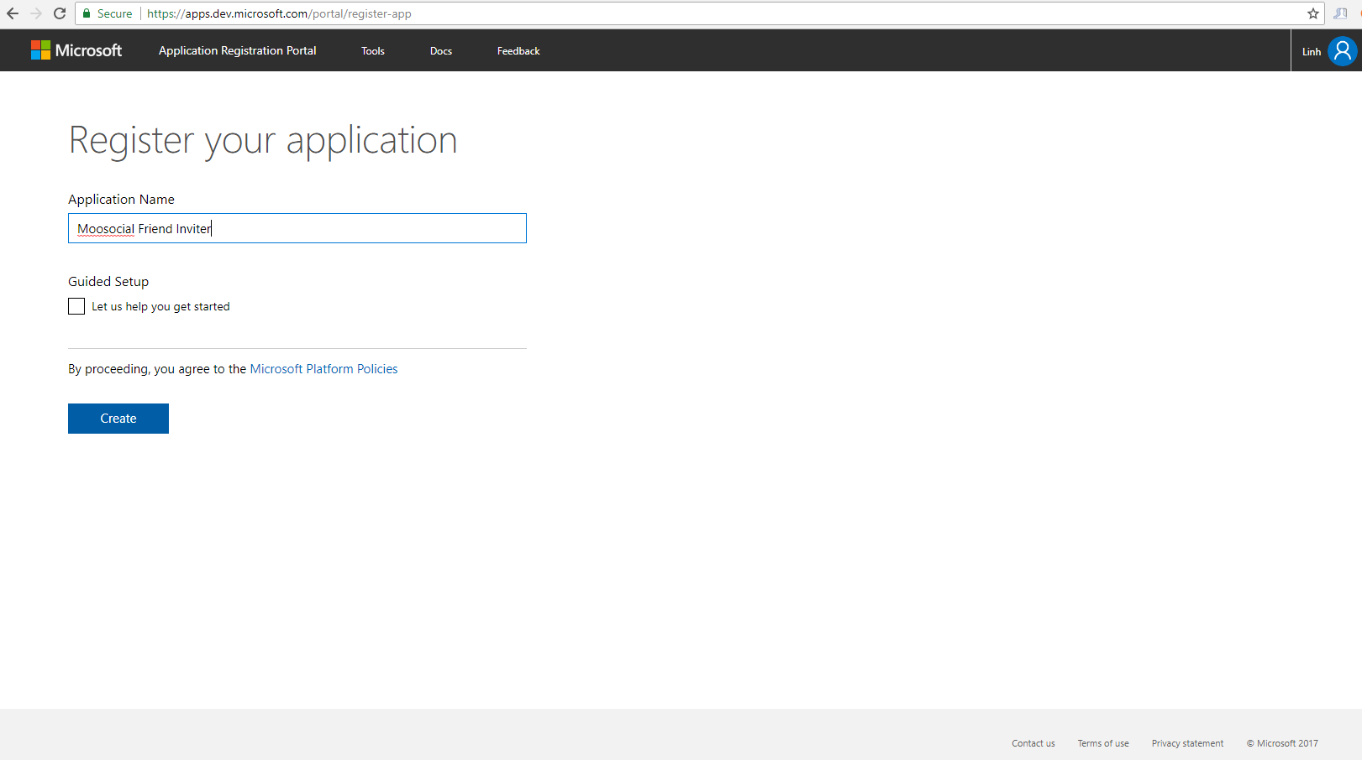

- On Registration App page, click “Add Platform”, the “Add Platform” popup will be open, continue choose Web

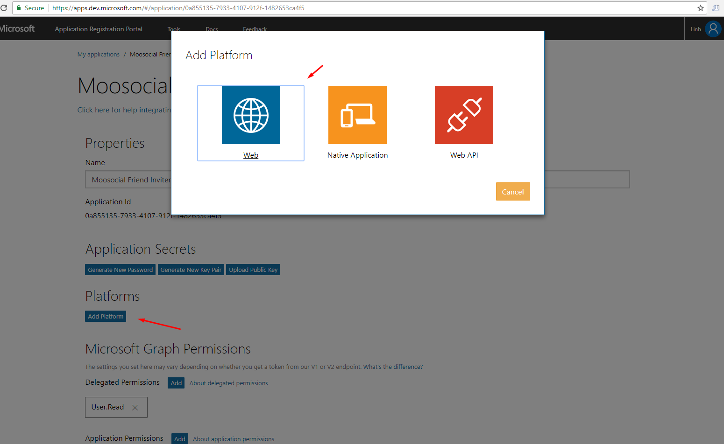

- Adding the exact Redirect URL: [url_your_site]/friend_inviters/getcontacts/livedone (Example : https://www.mysite.com/friend_inviters/getcontacts/livedone), then click “Create” (Your URL must begin with https://)
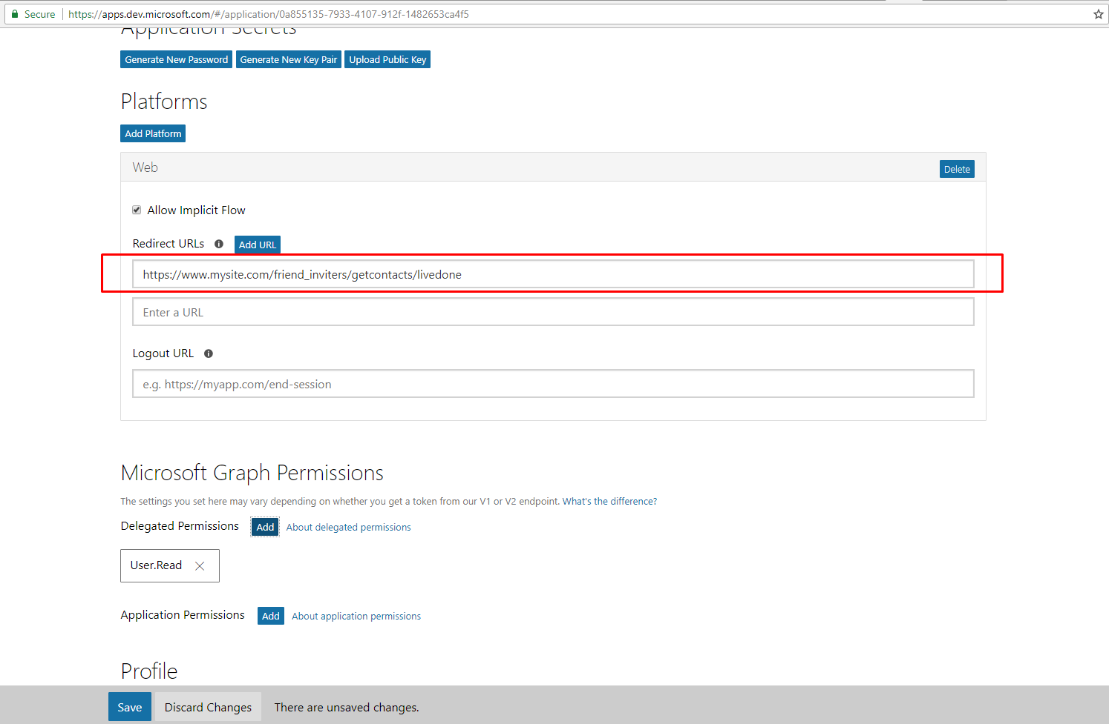

- In Microsoft Graph Permissions area, click “Add” Delegated Permissions, the Select Permission popup will be open, continue check on “Contacts.Read” then click “OK”
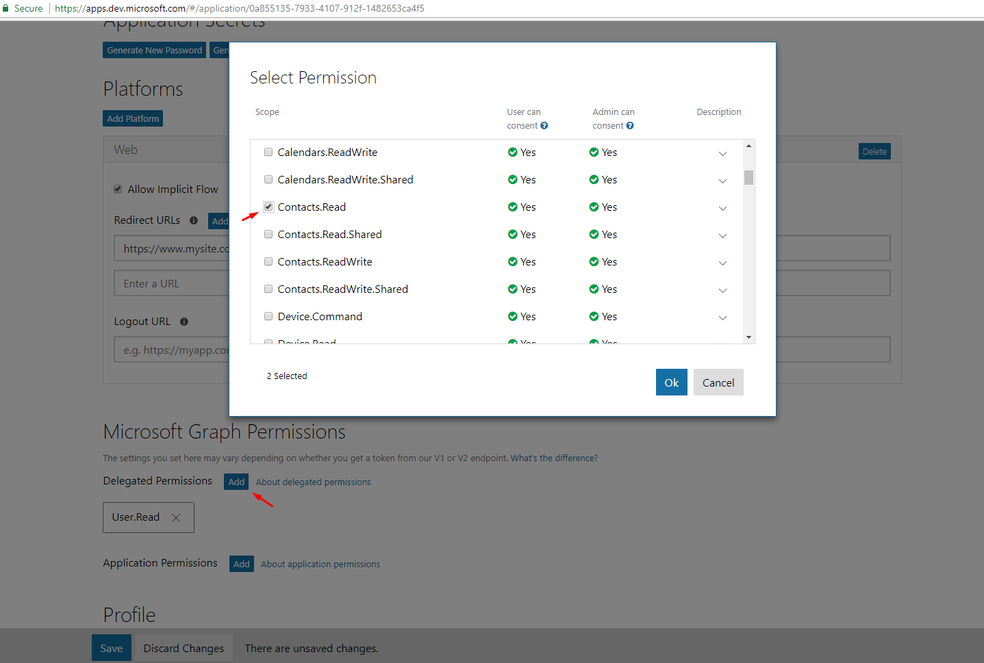

- Click Save button to save your app infos
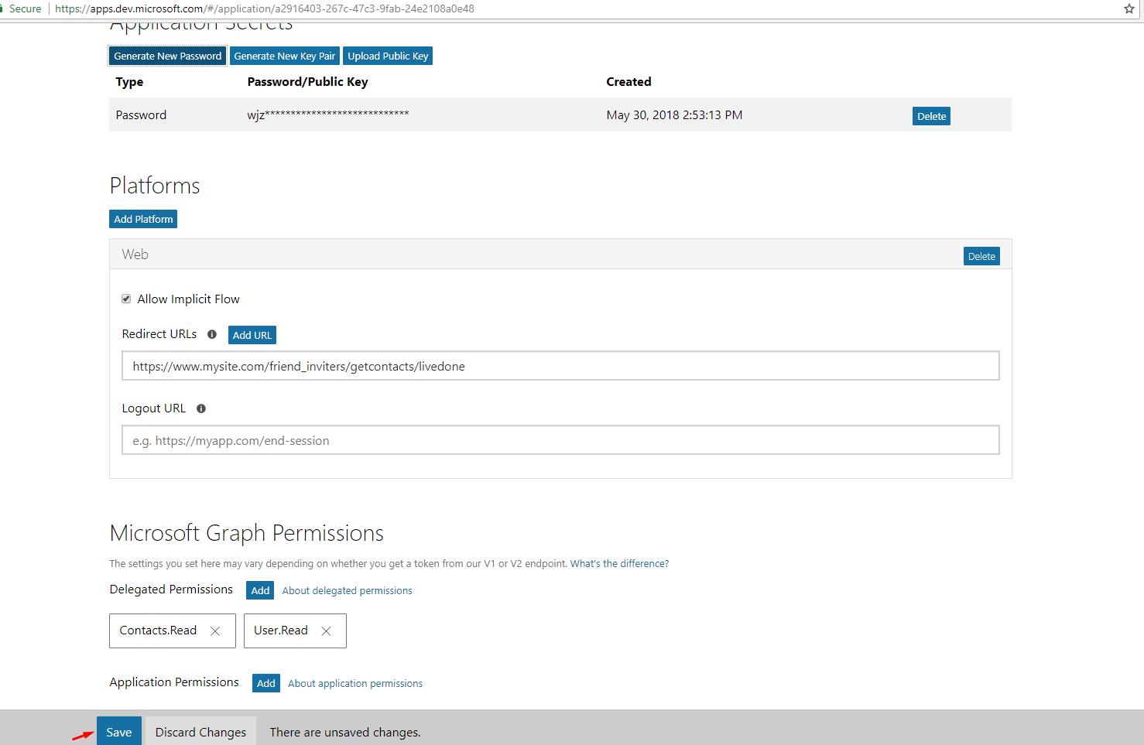
- Click on “Generate New Password”, copy Application ID and new generated password, then paste these values to your site's Window Live Contact Importer Settings fields

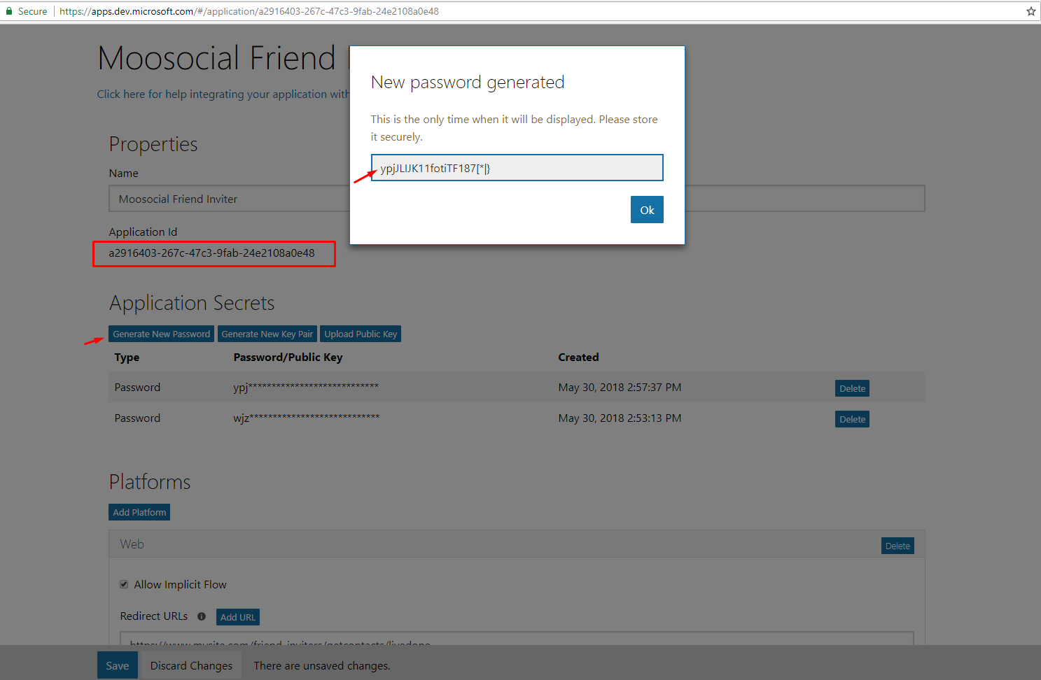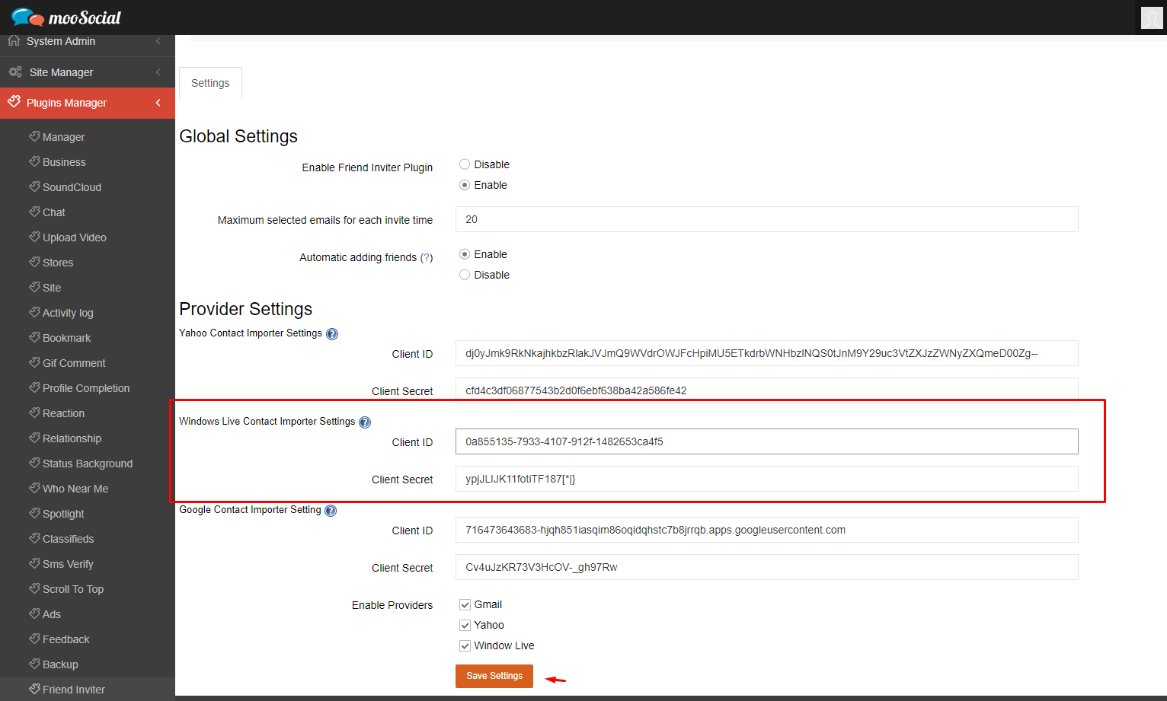

- Finally, click “Save Setting” to save Window Live Contact Importer Settings

